About Java exceptions

From the Course Description, p24:
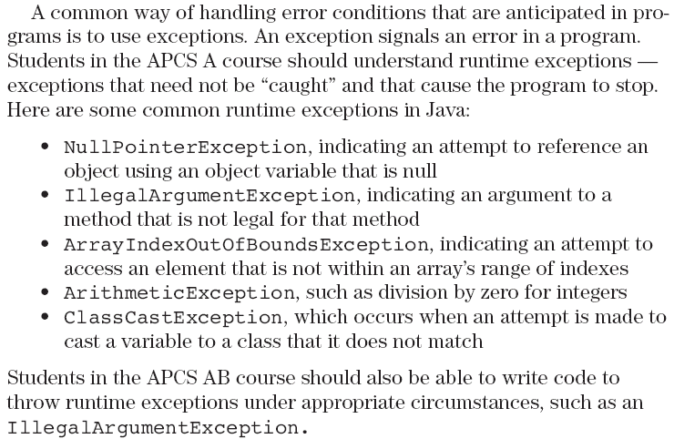

From p133:
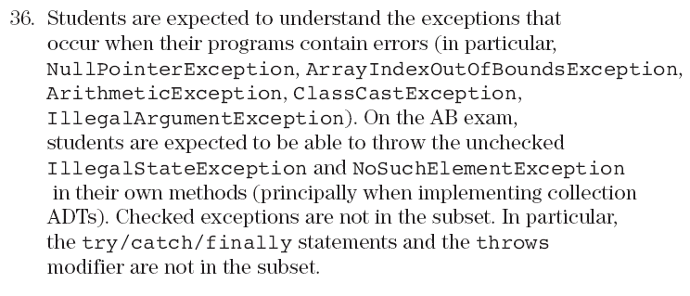

Unchecked exceptions are instances of the class java.lang.RuntimeException (or of its subclasses). All other exceptions are checked exceptions. The basic distinction is that a RuntimeException is one that can occur "almost anywhere," while a checked exception will occur only in the context of a specific activity. Unchecked exceptions halt the program; checked exceptions just invoke the exception-handler.
Exception CHECKED
IOException CHECKED
AWTException CHECKED
RunTimeException
ArithmeticException
IllegalArgumentException
NumberFormatException
IndexOutOfBoundsException
Others
Others CHECKED
A summary is here: http://www.cs.uno.edu/~fred/OOJ/Utilities/Companion/compExcep.html

